

[**Selenium Easy**](https://www.seleniumeasy.com/)

Here is below commands to execute 'testng.xml' file from command line

**cd** F:\Selenium\SampleTestNG

java -cp F:\Selenium\SampleTestNG\lib\*;F:\Selenium\SampleTestNG\bin org.testng.TestNG testng.xml

Execute Testng.xml from command line

[Home](https://www.seleniumeasy.com/) >> [TestNG Tutorials](https://www.seleniumeasy.com/testng-tutorials) >> [Execute Testng.xml from command line](https://www.seleniumeasy.com/testng-tutorials/how-to-run-testng-xml-webdriver-tests-from-command-line)

We can execute testng.xml file in different ways.

1. Eclipse  
2. InteliJ  
3. Ant / Maven  
4. Command Line  
5. Batch File.

In IDE you can just right click on testng.xml file and click on Run as 'TestNG' will invoke your tests. And we can also [invoke TestNG.xml with Ant build.xml file](http://www.seleniumeasy.com/ant-tutorials/how-to-run-testng-tests-using-build-xml-file) and we also by doing some simple [configuration to maven pom.xml](http://www.seleniumeasy.com/maven-tutorials/how-to-execute-selenium-webdriver-testng-xml-using-maven) which we have see examples earlier

Now let us see how to invoke testng.xml from command line step by step:

**Step 1:** Create new project, In example we have created project 'SampleTestNG'

**Step 2:** Create new package. 'com.test' as example package created here.

**Step 3:** Create sample classes which has @Test methods. In the example below we have created four classes as below :

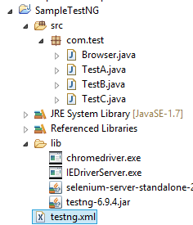

Class - Browser.java, which has getBrowser(String browserType) method which accepts browser Type and returns driver based on the string passed by the user.

**package** com.test;

**import** org.openqa.selenium.WebDriver;

**import** org.openqa.selenium.chrome.ChromeDriver;

**import** org.openqa.selenium.firefox.FirefoxDriver;

**import** org.openqa.selenium.ie.InternetExplorerDriver;

**public** **class** **Browser** {

**static** String driverPath = "F:/Selenium/SampleTestNG/lib/";

**public** **static** WebDriver driver;

**public** **static** WebDriver **getBrowser**(String browserType) {

**switch** (browserType) {

**case** "firefox":

**return** driver = **new** FirefoxDriver();

**case** "chrome":

System.setProperty("webdriver.chrome.driver", driverPath+"chromedriver.exe");

**return** driver = **new** ChromeDriver();

**case** "IE":

System.setProperty("webdriver.ie.driver", driverPath+"IEDriverServer.exe");

**return** driver = **new** InternetExplorerDriver();

**default**:

System.out.println("browser : " + browserType + " is invalid, Launching Firefox as browser of choice..");

**return** driver = **new** FirefoxDriver();

}

}

}

We will now try to create three different classes each passing different browser type (Firefox, chrome and InternetExplorer) and create test method in each class.

First create a class and get browser firefox :

**package** com.test;

**import** org.openqa.selenium.WebDriver;

**import** org.testng.Assert;

**import** org.testng.annotations.AfterClass;

**import** org.testng.annotations.BeforeClass;

**import** org.testng.annotations.Test;

**public** **class** **TestA** {

WebDriver driver;

@BeforeClass

**public** **void** **setUp**() {

System.out.println("*******************");

System.out.println("launching firefox browser");

driver = Browser.getBrowser("firefox");

driver.manage().window().maximize();

}

@Test

**public** **void** **testGooglePageTitleInFirefox**() {

driver.navigate().to("[http://www.google.com"](http://www.google.com/));

String strPageTitle = driver.getTitle();

Assert.assertTrue(strPageTitle.equalsIgnoreCase("Google"), "Page title doesn't match");

}

@AfterClass

**public** **void** **tearDown**() {

**if**(driver!=**null**) {

System.out.println("Closing firefox browser");

driver.quit();

}

}

}

Create another class 'TestB.java' and get browser chrome driver to [execute tests in chrome browser](http://www.seleniumeasy.com/selenium-tutorials/how-to-run-webdriver-in-chrome-browser) :

**package** com.test;

**import** org.openqa.selenium.WebDriver;

**import** org.testng.Assert;

**import** org.testng.annotations.AfterClass;

**import** org.testng.annotations.BeforeClass;

**import** org.testng.annotations.Test;

**public** **class** **TestB** {

WebDriver driver;

@BeforeClass

**public** **void** **setUp**() {

System.out.println("*******************");

System.out.println("launching chrome browser");

driver = Browser.getBrowser("chrome");

driver.manage().window().maximize();

}

@Test

**public** **void** **testGooglePageTitleInChrome**() {

driver.navigate().to("[http://www.google.com"](http://www.google.com/));

String strPageTitle = driver.getTitle();

Assert.assertTrue(strPageTitle.equalsIgnoreCase("Google"), "Page title doesn't match");

}

@AfterClass

**public** **void** **tearDown**() {

**if**(driver!=**null**) {

System.out.println("Closing chrome browser");

driver.quit();

}

}

}

Create another class 'TestC.java' and get browser chrome driver to [execute tests in IE browser](http://www.seleniumeasy.com/selenium-tutorials/how-to-run-webdriver-in-ie-browser):

**package** com.test;

**import** org.openqa.selenium.WebDriver;

**import** org.testng.Assert;

**import** org.testng.annotations.AfterClass;

**import** org.testng.annotations.BeforeClass;

**import** org.testng.annotations.Test;

**public** **class** **TestC** {

WebDriver driver;

@BeforeClass

**public** **void** **setUp**() {

System.out.println("*******************");

System.out.println("launching IE browser");

driver = Browser.getBrowser("IE");

driver.manage().window().maximize();

}

@Test

**public** **void** **testGooglePageTitleInIEBrowser**() {

driver.navigate().to("[http://www.google.com"](http://www.google.com/));

String strPageTitle = driver.getTitle();

System.out.println("Page title: - "+strPageTitle);

Assert.assertTrue(strPageTitle.equalsIgnoreCase("Google"), "Page title doesn't match");

}

@AfterClass

**public** **void** **tearDown**() {

**if**(driver!=**null**) {

System.out.println("Closing IE browser");

driver.quit();

}

}

}

The below is the testng.xml file, which will execute all the tests that are available under 'com.test' package.

In the above classes, each class has a test method with @Before and @After class which will open browser, validate Google Home page title and close browser. In IDE, it is very simple to execute to click on Run as TestNG.

The below is the testng.xml file

<?xml version="1.0" encoding="UTF-8"?>

<!DOCTYPE suite SYSTEM "[http://testng.org/testng-1.0.dtd"](http://testng.org/testng-1.0.dtd) >

<**suite** name="Main Test Suite" verbose="2">

    <**test** name="TestNG Test Group">

*<!-- <classes>*

*<class name="com.test.TestA"/>*

*</classes> -->*

        <**packages**>

        <**package** name="com.test"/>

        </**packages**>

    </**test**>

</**suite**>

Here is below commands to execute 'testng.xml' file from command line

**cd** F:\Selenium\SampleTestNG

java -cp F:\Selenium\SampleTestNG\lib\*;F:\Selenium\SampleTestNG\bin org.testng.TestNG testng.xml

After executing above command, it should execute the tests that we have specified in testng.xml file. And the below is the screen shot after executing the tests.

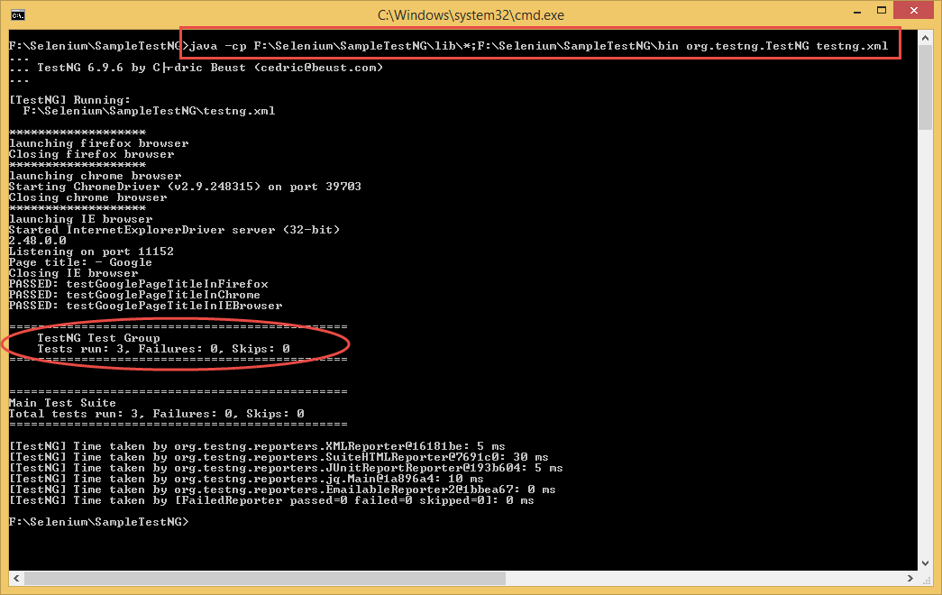

In the above command, for 'java -cp' argument, we provide the classpath i.e. path to classes / libraries that our program requires to run. You can check out [Oracle Docs](http://docs.oracle.com/javase/6/docs/technotes/tools/windows/classpath.html) for more information on class path.

* [‹ How to Install Jenkins](https://www.seleniumeasy.com/jenkins-tutorials/install-jenkins-via-command-line)
* [Execute Testng.xml using batch file ›](https://www.seleniumeasy.com/testng-tutorials/how-to-run-testng-xml-via-batch-file-example)

**Test Frameworks:**

[TestNG Tutorials](https://www.seleniumeasy.com/testng-tutorials)

* [Add new comment](https://www.seleniumeasy.com/testng-tutorials/how-to-run-testng-xml-webdriver-tests-from-command-line#comment-form)

Comments

[Hi....](https://www.seleniumeasy.com/comment/3491#comment-3491)

[*Permalink*](https://www.seleniumeasy.com/comment/3491#comment-3491)*Submitted by Viewer on Sat, 03/05/2016 - 03:54*

I'm getting following error on executing testng.xml from command prompt - Error - Couldn't find or load main class.

* [reply](https://www.seleniumeasy.com/comment/reply/194/3491)

[execute testng file](https://www.seleniumeasy.com/comment/12383#comment-12383)

[*Permalink*](https://www.seleniumeasy.com/comment/12383#comment-12383)*Submitted by anonymous on Thu, 04/27/2017 - 12:49*

If you are still facing that issue try this, JVM should know where the testng jar file is, the classpath that you are giving may not contains testng jar file, add testng jar file to libs, if you have added testng as a plugin in eclipse you will find it in the plugins of eclipse(in users). It will be less than 1mb. Add it and run the batch file(not from jenkins) if it works proceed to jenkins.﻿

* [reply](https://www.seleniumeasy.com/comment/reply/194/12383)

[Thank you](https://www.seleniumeasy.com/comment/14833#comment-14833)

[*Permalink*](https://www.seleniumeasy.com/comment/14833#comment-14833)*Submitted by Purna Pattanayak on Tue, 09/19/2017 - 01:38*

Thank you sir i was getting this issue that couldnot load org.testng.TestNG class ..after your suggestion i combine jars of testng to eclipse plugin and the problem got solve

* [reply](https://www.seleniumeasy.com/comment/reply/194/14833)

[Hello Permalink](https://www.seleniumeasy.com/comment/14803#comment-14803)

[*Permalink*](https://www.seleniumeasy.com/comment/14803#comment-14803)*Submitted by Snehal on Sat, 09/02/2017 - 12:36*

Try to keep your "lib" folder which contains all the jars outside the src folder. This might solve your problem

* [reply](https://www.seleniumeasy.com/comment/reply/194/14803)

[how to run testng.xml? i am getting error while run this comman](https://www.seleniumeasy.com/comment/14735#comment-14735)

[*Permalink*](https://www.seleniumeasy.com/comment/14735#comment-14735)*Submitted by mmr on Thu, 07/13/2017 - 05:07*

C:\Program Files\MohanWorkSpace\CM_Desktop>java -cp bin;lib/* org.testng.TestNG\  
testng.xml  
Error: Could not find or load main class org.testng.TestNG\testng.xml

C:\Program Files\MohanWorkSpace\CM_Desktop>

* [reply](https://www.seleniumeasy.com/comment/reply/194/14735)

[Not able to run same in CMD](https://www.seleniumeasy.com/comment/14744#comment-14744)

[*Permalink*](https://www.seleniumeasy.com/comment/14744#comment-14744)*Submitted by Jayant Gupta on Wed, 07/19/2017 - 08:38*

There is some path issue coming on console, lib path that i am using is D:\C drive back up\workspace1\Jcb\lib\*  
Getting error could not find or load main class drive

* [reply](https://www.seleniumeasy.com/comment/reply/194/14744)

[cannot load class file](https://www.seleniumeasy.com/comment/14852#comment-14852)

[*Permalink*](https://www.seleniumeasy.com/comment/14852#comment-14852)*Submitted by haime on Wed, 10/04/2017 - 11:25*

Hello,  
I get this error. Any idea why? class files are all in bin folder. Thanks!

c:\eclipse2\Workspace\NDM3a>java -cp org.testng.TestNG testng.xml  
Error: Could not find or load main class testng.xml

c:\eclipse2\Workspace\NDM3a>java org.testng.TestNG testng.xml  
[TestNG] [ERROR]  
Cannot find class in classpath: PageObject.NDM_TestSuite

* [reply](https://www.seleniumeasy.com/comment/reply/194/14852)

[Cannot Find Class in Classpath](https://www.seleniumeasy.com/comment/15177#comment-15177)

[*Permalink*](https://www.seleniumeasy.com/comment/15177#comment-15177)*Submitted by Manjeera on Tue, 08/07/2018 - 06:54*

I tried to run using above method but getting Cannot find class in classpath , I have included jar files in my lib folder also.  
Do we need to create bin folder and add here:  
F:\Selenium\SampleTestNG\bin

* [reply](https://www.seleniumeasy.com/comment/reply/194/15177)

[how to pass dynamic value from cmd line to testng.xml](https://www.seleniumeasy.com/comment/22724#comment-22724)

[*Permalink*](https://www.seleniumeasy.com/comment/22724#comment-22724)*Submitted by raja on Tue, 09/17/2019 - 09:05*

I want to dynamically decide which group of test cases to get executed by passing the group name from cmd line, but the  
<groups>  
<run> <!-- group name --></run>  
</groups>  
is present in testng.xml. how should i pass cmd line property value to testng.xml, please help.

* [reply](https://www.seleniumeasy.com/comment/reply/194/22724)

[After adding -cp, it worked.](https://www.seleniumeasy.com/comment/23153#comment-23153)

[*Permalink*](https://www.seleniumeasy.com/comment/23153#comment-23153)*Submitted by GV on Mon, 12/09/2019 - 05:12*

After adding -cp, it worked.

Thanks

* [reply](https://www.seleniumeasy.com/comment/reply/194/23153)

Add new comment

Your name

Subject

Comment *

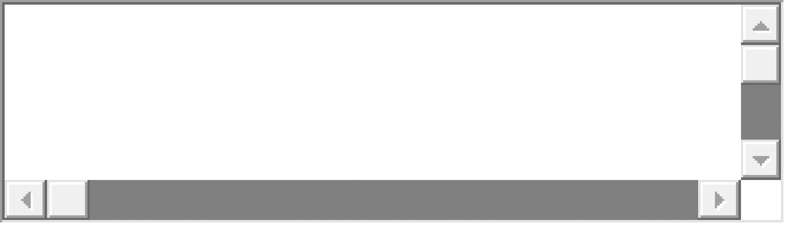

[More information about text formats](https://www.seleniumeasy.com/filter/tips)

 Save Preview



Testng Articles

* [TestNG Introduction](https://www.seleniumeasy.com/testng-tutorials/testng-introduction)
* [How to Install TestNG step by step](https://www.seleniumeasy.com/testng-tutorials/how-to-install-testng-step-by-step)
* [DataProvider in TestNG](https://www.seleniumeasy.com/testng-tutorials/dataprovider-in-testng)
* [TestNG XML example to execute with package names](https://www.seleniumeasy.com/testng-tutorials/testngxml-example-to-execute-with-package-names)
* [TestNG XML example to execute Multiple Classes](https://www.seleniumeasy.com/testng-tutorials/testngxml-example-to-execute-with-class-names)
* [Groups in TestNG](https://www.seleniumeasy.com/testng-tutorials/groups-in-testng-examples)
* [Exception Test in TestNG](https://www.seleniumeasy.com/testng-tutorials/exception-test-in-testng)
* [Skip Exception Test in TestNG](https://www.seleniumeasy.com/testng-tutorials/skip-test-in-testng)
* [Timeout Test in TestNG](https://www.seleniumeasy.com/testng-tutorials/timeout-test-in-testng)
* [TestNG Test Case Priority](https://www.seleniumeasy.com/testng-tutorials/testng-test-case-priority)
* [Configuring ReportNG with TestNG for HTML Reports](https://www.seleniumeasy.com/testng-tutorials/configuring-reportng-with-testng-to-generate-html-reports)
* [Logging with TestNG using Listeners](https://www.seleniumeasy.com/testng-tutorials/logging-with-testng-using-listeners)
* [Class level annotations in TestNG](https://www.seleniumeasy.com/testng-tutorials/class-level-annotations-in-testng)
* [Multiple Tests with TestNG.XML](https://www.seleniumeasy.com/testng-tutorials/multiple-tests-in-testng-xml)
* [Include and Exclude Test Methods in TestNG](https://www.seleniumeasy.com/testng-tutorials/include-exclude-test-methods-in-testng)
* [Parameterization in TestNG using testng.xml](https://www.seleniumeasy.com/testng-tutorials/parameterization-in-testng)
* [Parallel Execution of test methods in TestNG](https://www.seleniumeasy.com/testng-tutorials/parallel-execution-of-test-methods-in-testng)
* [Parallel Execution of Classes in TestNG](https://www.seleniumeasy.com/testng-tutorials/parallel-execution-of-classes-in-testng)
* [Preserver Order in Testng](https://www.seleniumeasy.com/testng-tutorials/preserve-order-in-testng)
* [Assertions in TestNG](https://www.seleniumeasy.com/testng-tutorials/assertions-in-testng)
* [Retry executing only Failed Tests using TestNG](https://www.seleniumeasy.com/testng-tutorials/execute-only-failed-test-cases-using-iretryanalyzer)
* [TestNG Tests Run Count after Retry.](https://www.seleniumeasy.com/testng-tutorials/retry-listener-failed-tests-count-update)
* [Taking ScreenShot ONLY for Failed Tests](https://www.seleniumeasy.com/testng-tutorials/how-to-take-screenshot-for-only-failed-tests-using-webdriver)
* [Take Screenshot and place it in a folder with Test Class name](https://www.seleniumeasy.com/testng-tutorials/take-screenshot-with-webdriver-and-place-it-in-a-folder-with-test-class-name)
* [Passing data to DataProvider from Excel sheet](https://www.seleniumeasy.com/testng-tutorials/import-data-from-excel-and-pass-to-data-provider)
* [Optional annotation in TestNG](https://www.seleniumeasy.com/testng-tutorials/optional-annotation-in-testng)
* [Customize TestNG html Report](https://www.seleniumeasy.com/testng-tutorials/testng-customize-emailable-html-report-example)
* [Execute Testng.xml from command line](https://www.seleniumeasy.com/testng-tutorials/how-to-run-testng-xml-webdriver-tests-from-command-line)
* [Execute Testng.xml using batch file](https://www.seleniumeasy.com/testng-tutorials/how-to-run-testng-xml-via-batch-file-example)
* [IMethodInterceptor examples to reorder list of test methods](https://www.seleniumeasy.com/testng-tutorials/imethodinterceptor-example-to-reorder-tests)
* [Customize TestNG emailable report with screenshots](https://www.seleniumeasy.com/testng-tutorials/customized-testng-emailable-report2)
* [SoftAssert in TestNG example](https://www.seleniumeasy.com/testng-tutorials/soft-asserts-in-testng-example)
* [Allure report example using testng and maven](https://www.seleniumeasy.com/testng-tutorials/allure-example)
* [TestNG - Gradle example](https://www.seleniumeasy.com/testng-tutorials/using-testng-with-gradle)
* [Test Report with Retry Stacktrace and Screenshot](https://www.seleniumeasy.com/testng-tutorials/retry-stacktrace-and-screenshots-in-report)

[Selenium Popular Posts](https://www.seleniumeasy.com/testng-tutorials/how-to-run-testng-xml-webdriver-tests-from-command-line#collapseOne)

• [Page Factory Framework](https://www.seleniumeasy.com/selenium-tutorials/page-factory-pattern-in-selenium-webdriver)

• [POM example](https://www.seleniumeasy.com/selenium-tutorials/simple-page-object-model-framework-example)

• [Working with Selenium Grid](https://www.seleniumeasy.com/selenium-tutorials/how-to-configure-selenium-grid)

• [Click element with JavaScriptExecutor](https://www.seleniumeasy.com/selenium-tutorials/click-element-using-javascriptexecutor)

• [Css selectors examples](https://www.seleniumeasy.com/selenium-tutorials/css-selectors-tutorial-for-selenium-with-examples)

[TestNG Popular Posts](https://www.seleniumeasy.com/testng-tutorials/how-to-run-testng-xml-webdriver-tests-from-command-line#collapseTwo)

[Jenkins Popular Posts](https://www.seleniumeasy.com/testng-tutorials/how-to-run-testng-xml-webdriver-tests-from-command-line#collapseThree)

Tags Cloud

[Allure](https://www.seleniumeasy.com/tags/allure)

(1)

[Allure report](https://www.seleniumeasy.com/tags/allure-report)

(1)

[Appium Android](https://www.seleniumeasy.com/tags/appium-android)

(11)

[Appium IOS](https://www.seleniumeasy.com/tags/appium-ios)

(1)

[Asserts](https://www.seleniumeasy.com/tags/asserts)

(2)

[AutoComplete](https://www.seleniumeasy.com/tags/autocomplete)

(1)

[AutoIt](https://www.seleniumeasy.com/tags/autoit)

(2)

[Automation](https://www.seleniumeasy.com/taxonomy/term/37)

(5)

[Build.xml](https://www.seleniumeasy.com/tags/buildxml)

(1)

[Checkboxes](https://www.seleniumeasy.com/tags/checkboxes)

(2)

[Cloud Execution](https://www.seleniumeasy.com/tags/cloud-execution)

(1)

[Codeless Automation Testing](https://www.seleniumeasy.com/tags/codeless-automation-testing)

(1)

[Cookies](https://www.seleniumeasy.com/tags/cookies)

(3)

[Css](https://www.seleniumeasy.com/tags/css)

(2)

[Css Examples](https://www.seleniumeasy.com/tags/css-examples)

(2)

[Database Testing](https://www.seleniumeasy.com/tags/database-testing)

(2)

[DataProvider](https://www.seleniumeasy.com/tags/dataprovider)

(1)

[Date Picker](https://www.seleniumeasy.com/tags/date-picker)

(1)

[desktop app testing](https://www.seleniumeasy.com/tags/desktop-app-testing)

(1)

[Drag and Drop](https://www.seleniumeasy.com/tags/drag-and-drop)

(1)

[Excel](https://www.seleniumeasy.com/tags/excel)

(5)

[Exceptions](https://www.seleniumeasy.com/tags/exceptions)

(4)

[Extent Report](https://www.seleniumeasy.com/tags/extent-report)

(2)

[File Download](https://www.seleniumeasy.com/tags/file-download)

(3)

[Firefox Profile](https://www.seleniumeasy.com/tags/firefox-profile)

(2)

[Frameworks](https://www.seleniumeasy.com/tags/frameworks)

(6)

[Grid](https://www.seleniumeasy.com/tags/grid)

(5)

[iFrames](https://www.seleniumeasy.com/tags/iframes)

(1)

[Images](https://www.seleniumeasy.com/tags/images)

(1)

[Interview Questions](https://www.seleniumeasy.com/taxonomy/term/45)

(1)

[JavascriptExecutor](https://www.seleniumeasy.com/tags/javascriptexecutor)

(3)

[Jenkins](https://www.seleniumeasy.com/tags/jenkins)

(1)

[JMeter Assertion Examples](https://www.seleniumeasy.com/tags/jmeter-assertion-examples)

(2)

[JUnit](https://www.seleniumeasy.com/taxonomy/term/35)

(2)

[Katalon](https://www.seleniumeasy.com/tags/katalon)

(2)

[Katalon Studio](https://www.seleniumeasy.com/tags/katalon-studio)

(5)

[Keyword Driven](https://www.seleniumeasy.com/tags/keyword-driven)

(1)

[Listeners](https://www.seleniumeasy.com/tags/listeners)

(9)

[Locators](https://www.seleniumeasy.com/tags/locators)

(2)

[Log4j](https://www.seleniumeasy.com/tags/log4j)

(4)

[log4j.xml](https://www.seleniumeasy.com/tags/log4jxml)

(1)

[Manual Testing](https://www.seleniumeasy.com/taxonomy/term/40)

(1)

[Maven](https://www.seleniumeasy.com/tags/maven)

(6)

[Mouse Hover](https://www.seleniumeasy.com/tags/mouse-hover)

(2)

[Page Object Model](https://www.seleniumeasy.com/tags/page-object-model)

(4)

[Page Scroll](https://www.seleniumeasy.com/tags/page-scroll)

(1)

[Parallel Test](https://www.seleniumeasy.com/tags/parallel-test)

(3)

[Performance Testing](https://www.seleniumeasy.com/tags/performance-testing)

(10)

[Processors](https://www.seleniumeasy.com/tags/processors)

(2)

[properties file](https://www.seleniumeasy.com/tags/properties-file)

(1)

Follow Us

* [Flipkart](https://dl.flipkart.com/dl/?affid=kdevendra3)
* [Amazon IN](https://www.amazon.in/ref=as_li_ss_tl?ie=UTF8&linkCode=ll2&tag=seleeasy-21&linkId=134a04c9f4cc4a17135b32246e4ca4d9)

Menu

* [Selenium Tutorials](https://www.seleniumeasy.com/selenium-tutorials)
* [TestNG Tutorial](https://www.seleniumeasy.com/testng-tutorials)
* [JUnit Tutorial](https://www.seleniumeasy.com/junit-tutorials)
* [JXL Tutorial](https://www.seleniumeasy.com/jxl-tutorials)
* [Apache POI](https://www.seleniumeasy.com/apachepoi-tutorials)
* [ANT Tutorial](https://www.seleniumeasy.com/ant-tutorials)
* [Maven Tutorial](https://www.seleniumeasy.com/maven-tutorials)

Popular Posts

* [Gecko Driver Selenium 3](https://www.seleniumeasy.com/selenium-tutorials/launching-firefox-browser-with-geckodriver-selenium-3)
* [Page Factory Pattern](https://www.seleniumeasy.com/selenium-tutorials/page-factory-pattern-in-selenium-webdriver)
* [Execute Tests in Jenkins](https://www.seleniumeasy.com/jenkins-tutorials/invoke-testng-xml-tests-from-jenkins)
* [TestNG Custom Report](https://www.seleniumeasy.com/testng-tutorials/testng-customize-emailable-html-report-example)
* [Execute Selenium tests using Maven](https://www.seleniumeasy.com/maven-tutorials/how-to-execute-selenium-webdriver-testng-xml-using-maven)
* [View All Selenium Tutorials](https://www.seleniumeasy.com/selenium-webdriver-tutorials)

Subscribe to our mailing list





© 2016 Selenium Easy. All Rights Reserved.

[Home](https://www.seleniumeasy.com/)[About](https://www.seleniumeasy.com/about-us)[Contact](https://www.seleniumeasy.com/contact)[Privacy Policy](https://www.seleniumeasy.com/privacy-policy)[Sitemap](https://www.seleniumeasy.com/sitemap)[Android App](https://play.google.com/store/apps/details?id=com.seleniumeasy.seleniumeasy)

Share to FacebookShare to TwitterShare to EmailShare to LinkedIn